**Tableau Parts 11 and 12: Exercises with answers**

Exercise 11

1. Import the state_data.csv data into Tableau.
2. Make a map of Population for all States using Longitude and Latitude

Answer:

Drag:

* Longitude to columns
* Latitude to rows
* Population to the marks color panel
* State name to the detail panel

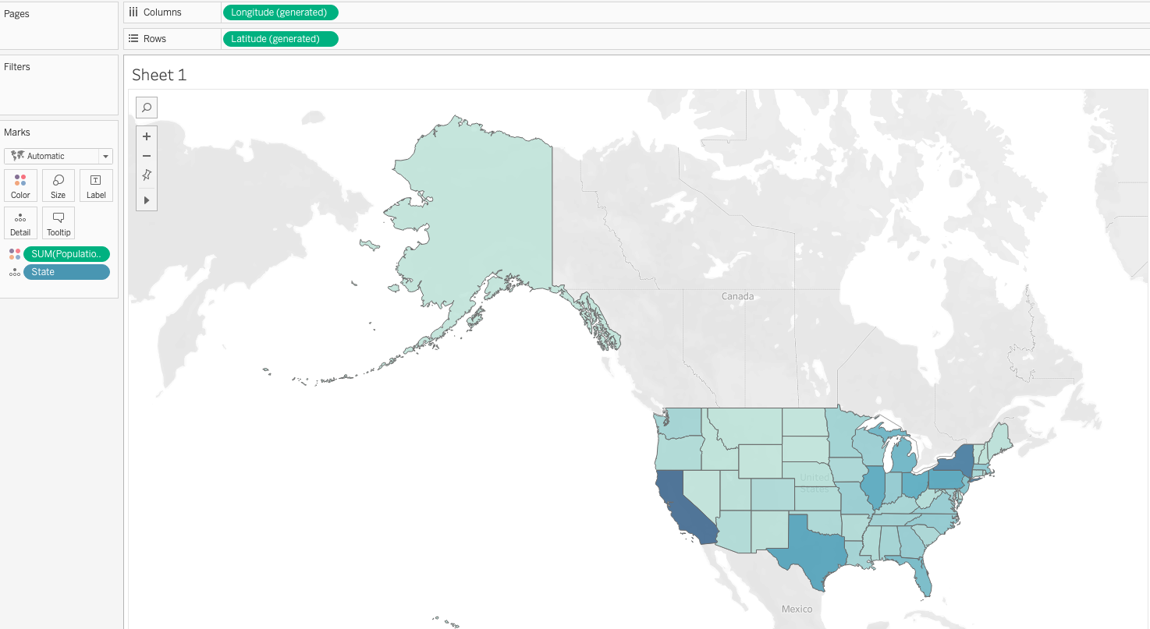

1. Insert a Map Scale using the Map option.

Answer: Map -> Map option -> Check Show Map Scales

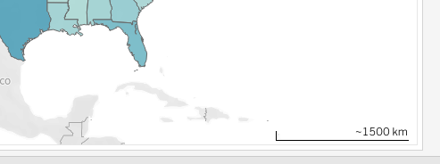

1. Using Map Layer options, change the style to Outdoors. Check the map options “Terrain” and “Water Labels.”

Answer: Map ->Background Layers

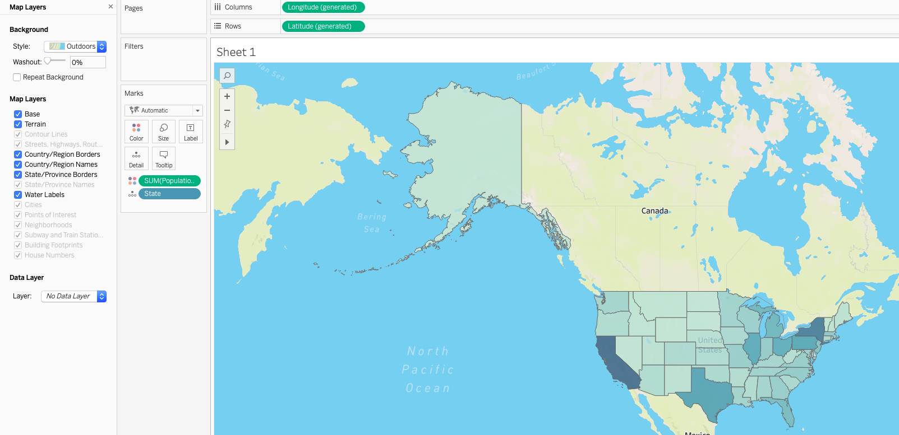

1. Zoom into the California area to have a better look at the state details.

Answer:

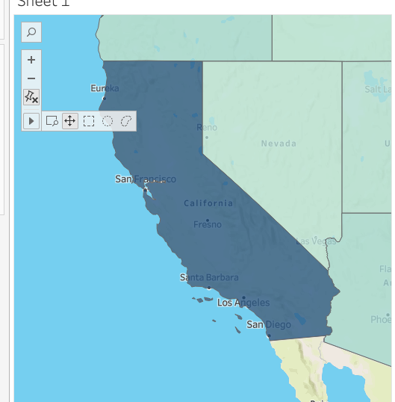

1. Convert the *‘code’* dimension to geospatial data to recognize that the codes are State codes. Replace the `State` variable with `code`.

Answer:

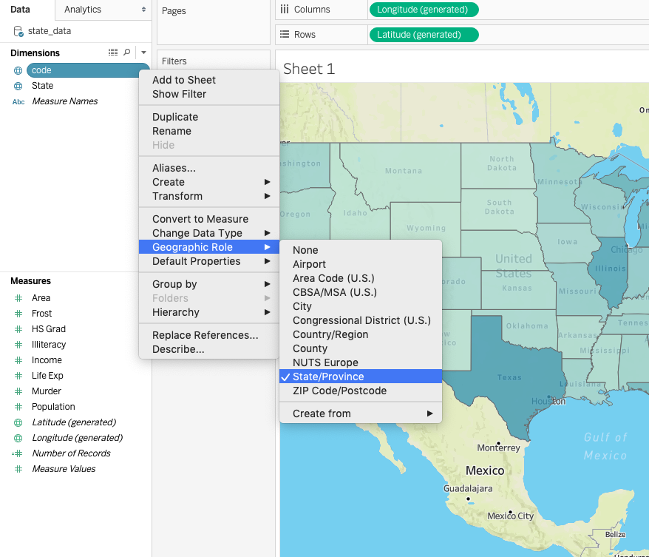

1. Identify the issues with the geospatial data when we switched to state codes.

Answer: Alaska is not shown on the map and there are two

unrecognized locations.

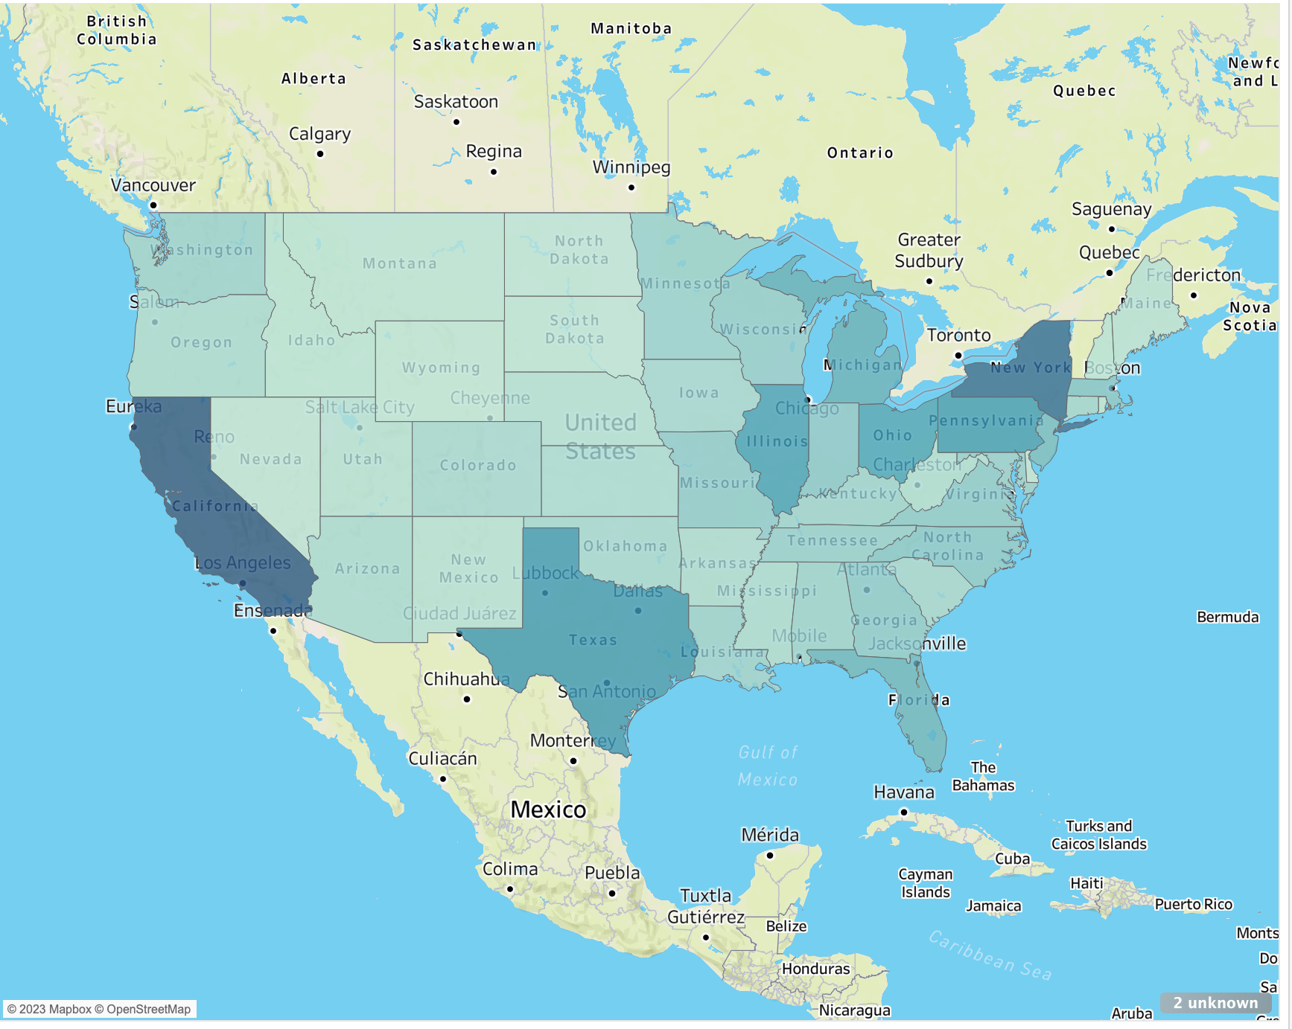

1. Fix the issues using the Edit Locations window. Update the locations for ‘Alaska’ and ‘Vermont.’ (Hint : Click on *‘unknown’* in bottom right corner of the map to open *‘Edit Locations’*)

Answer:

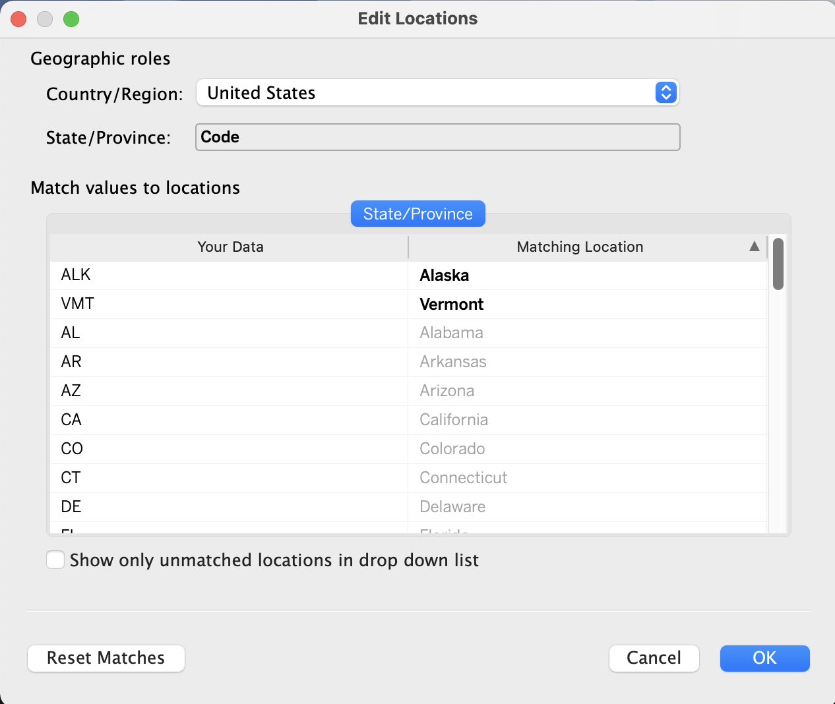

Exercise 12

Let your instructor know if you would like to share your dashboard as an example answer. Your dashboard will likely differ from your colleagues’.